Revelation Study:
Review:
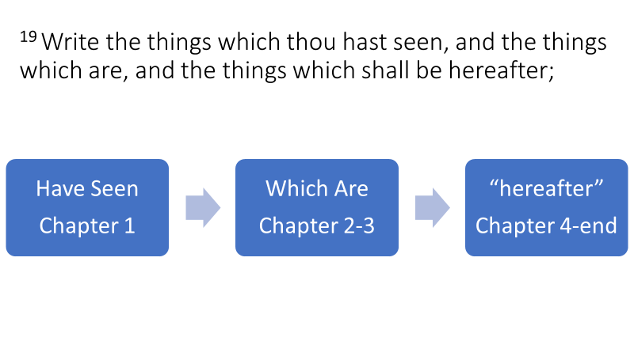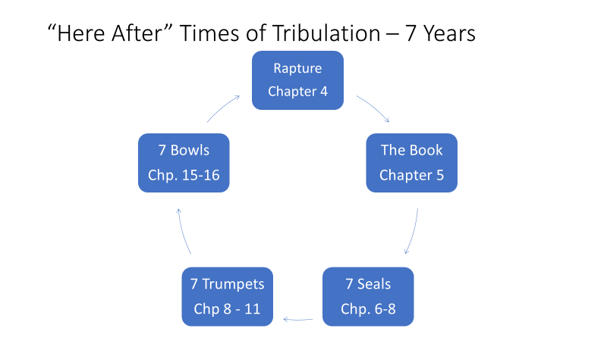
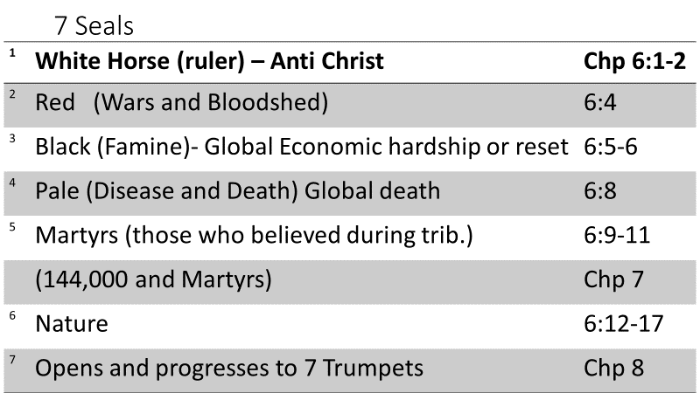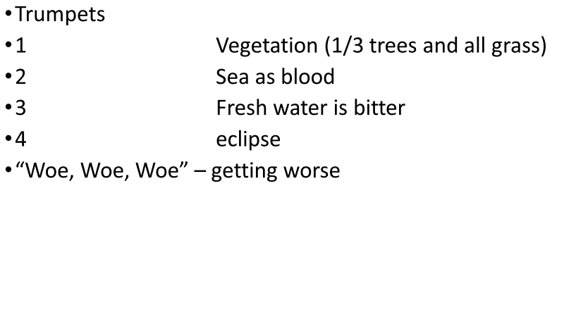
Chapter 9 notes:
The time period is at ……………………………………………………………….
The Star is identified as…………………………………………………………….
The Key represents……………………………………………………………………
The Bottomless pit speaks of the Abyss. In this study, we look at the grave in 3 aspects or rooms
Room 1 - Room 2 - Room 3-

Application #1 …………….. is now empty and moved into the third heavens because of………………
The 5th trumpet is the event of the releasing of a swarm of ………………………………………………
Application #2 -
Application #3 -

