Review:
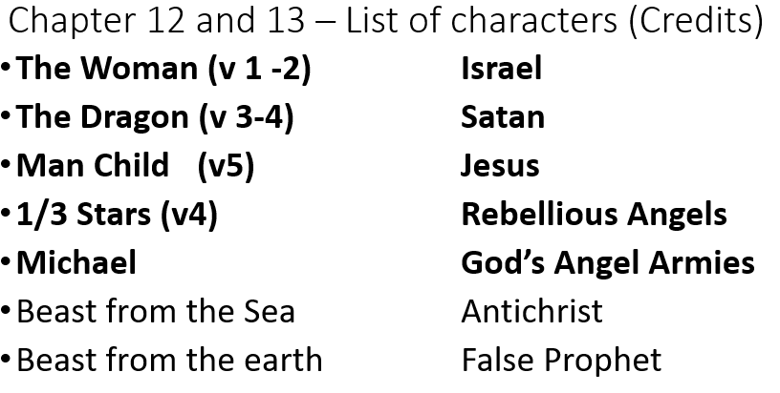

V 7 – 8 The Showdown –
Michael –
What do I learn about Angels?
How long is the Tribulation? At what time are we reading about?
War –
Access –

V 9 The Description –
Old serpent, Devil, Satan, Deceiver

V 10 The Preview –
Salvation, Power, Kingdom, Authority

V 11 The Victory –
Blood, Testimony, Love

V 12 – 17 The Persecution –
Persecution, Protection, Problem

